**Constraints, Flexibility and Penalties**

Constraints, Flexibility and Penalties are cardinal concepts to Optibus OnSchedule™ Preferences.

To explain these concepts, we start with an example.

In the **Work Limitation** preference, you are required to set the maximum work time for a duty. Here is part of the relevant dialog:

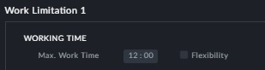

*Figure 1-1: Setting maximum working time*

If we enter 12 hours as shown, is becomes a rigid **constraint**. The optimizer will never allow a duty longer than 12 hours.

In practice, a constraint of this kind is not realistic. We would prefer a **flexibility** limit that allows a duty to run between 12 and 15 hours with a **penalty** for exceeding 12 hours. Here is how we do it:

In the dialog from which we extracted **Figure 1-1**, we check the box to the left of **Flex- ibility**. Two additional fields are opened:

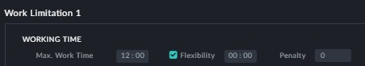

In the **Flexibility** field, enter 3 hours. In the **Penalty** field, enter 30, like this:

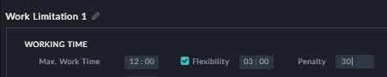

This tells the optimizer that w can accept a maximum working time from 2 to no more than 12+3=15 hours with a sliding penalty of 10 per hour increasing from 0 at 12 hours to 30 at 15 hours.

The **penalty** in this context, expresses what we are prepared to pay to exceed a certain minimum bound.

The penalty unit of currency is neutral. You need to ensure that relative pen-

alty rates reflect conditions in your locale.

Sliding penalties can operate in both directions in a single preference. Continuing from



the Work Limitation example, we see this:

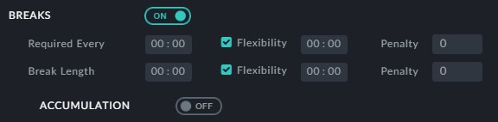

**Required Every** has a penalty for **exceeding** the required value: Typically, breaks are required after a maximum actual driving time. For example, a break of 30 min. might be required after 4 hours of continuous driving. It may not be realistic to set these two val- ues as restrictions. It may be more practical to allow an overrun of 2 hours by setting a **Flexibility** level of 2 hours with a penalty of say 20. The penalty is proportional, starting

at zero for no overrun to 20 for 2 hours.

**Break Length** flexibility works in the **opposite direction**. For a break of 30 min. we might set the Flexibility value to 15 min. and the penalty will increase as we decrease the break time. The penalty here is based on an **hourly** violation, not per minute.



Sliding penalties are not necessarily pro-rata (linear).

A penalty can be a **fixed** amount depending on something happening or not. Here is an

example from the **Driver Changeover Vehicle** preference:

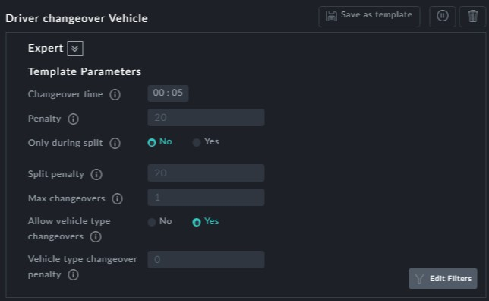

Both of the penalties shown here are fixed amounts. The **Changeover time** penalty is

incurred every time a driver switces vehicles. The **Split penalty** is incurred when a changeover takes place during a split break.